**User guide for Local Crypto Server**

Food-Chain Crypto is a Java program meant for hosting a local server. It listens to requests from Food-Chain Scanner App and sends encrypted response back. This program is meant to be hosted locally (WIFI) at every location of the food supply chain.

**Requirements:**

* Java 8 - http://www.oracle.com/technetwork/java/javase/downloads/jdk8-downloads-2133151.html
* NetBeans IDE - https://netbeans.org/downloads/

**How to build the app:**

1. Install/update latest NetBeans IDE

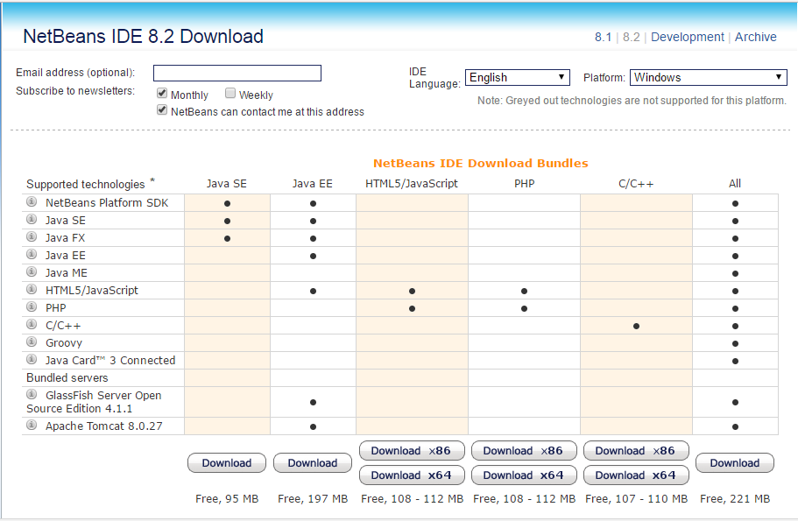

Download NetBeans IDE with Java SE or All(recommended). Download link is provided at the requirements section above.

1. Open the NetBeans IDE 8.2 and open the project file (Food-Chain Crypto).

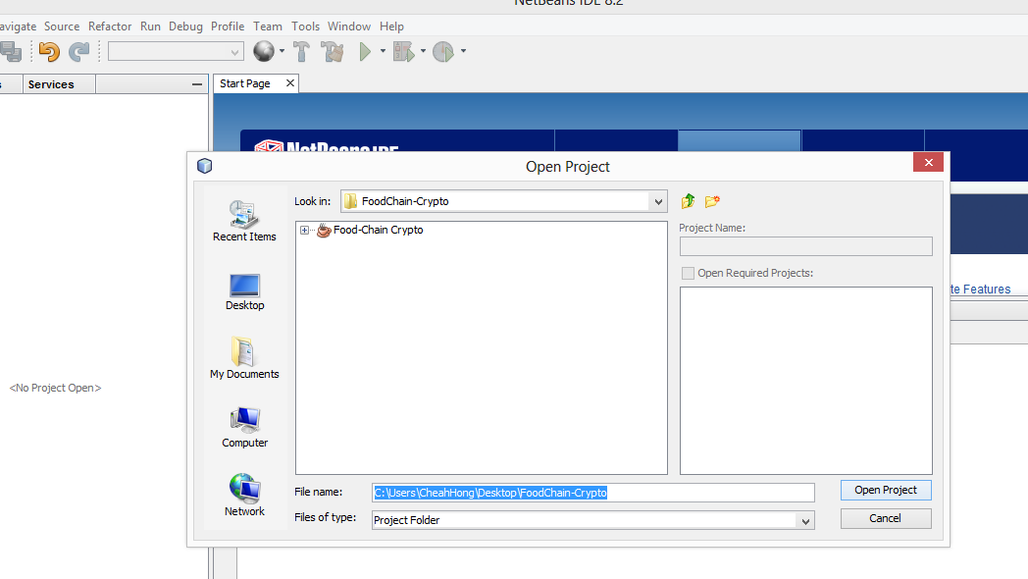

1. Customizing current location

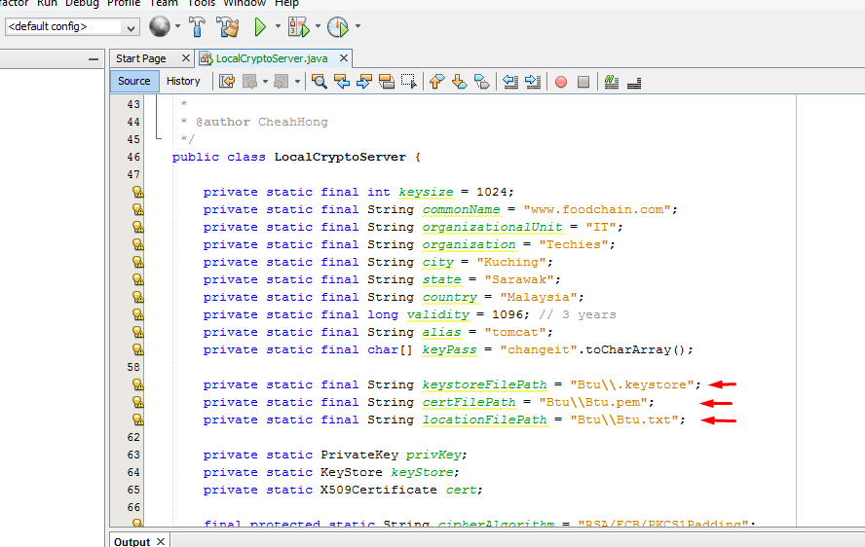

For demo purposes, currently there are three location folders available in the project file, namely Btu, Kch and Mri (Bintulu, Kuching, Miri ), which are the cities of Sarawak, Malaysia.

To change between locations, simply go to the LocalCryptoServer.java and change the string paths as shown in the diagram above. For instance, change the string “Kch\\Kch.pem” to “Btu\\Btu.pem” or “Mri\\Mri.pem”.

1. Run the project

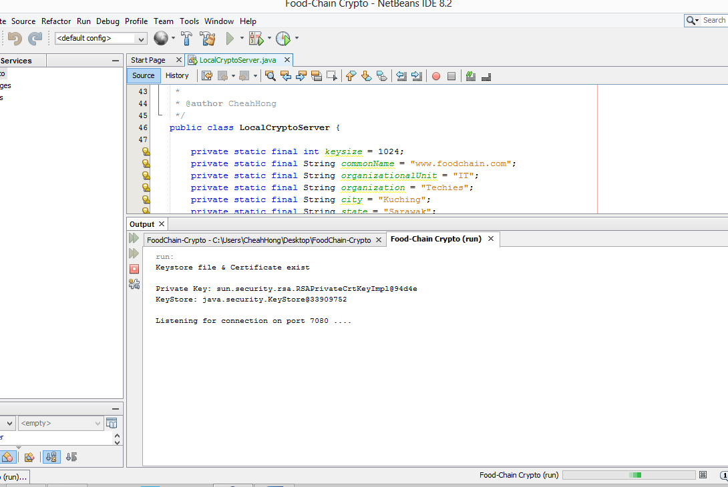

The program is now ready to receive requests from Food-Chain Scanner App.

**Open source library:**

* rt.jar (Java/jre1.8.0/lib)
* json-simple-1.1.1.jar

**Use Cases:**

1. A worker wants to scan product and send location information to Blockchain
2. The worker runs the Food-Chain Crypto program
3. Now the location information is ready to be sent to Food-Chain Scanner App